**Docks and Harbours**

**Introduction**

* Railways and road ways are common means of transportation. 2/3 rd of world occupied with water which proves importance of waterways. Majority of population lives with in 50 to 60km from coastal areas. All means of transportation requires specified path to travel. But water ways doesn’t requires any special tracks to travel. And more over waterways are common since hundreds of years, for travelling different countries connected by seas and oceans. Hollow wooden or metal vessels move on water by natural wind or power engines
* Boat 1st category
* Ships 2nd category

Water transportation further subdivided into 2 types

Types of transportation

1)Inland waterways

2)Ocean waterways

**Inland waterways**

**Ocean waterways**

**Advantages of waterways**

* Cheapest
* Greater carrying
* National defense
* Discoveries
* Development of commerce
* Development of international relationships
* Only means of transportation for certain places

**Disadvantages of waterways**

* Slow transportation
* More loss due to natural calamites
* Limited area of operation
* Zig-zag and circuitous routes
* International rules
* Blockades of waterways
* Seasonal character

**Harbor**

* it is basin or road stead of navigable waters well protected naturally or artificially from action of wind and waves and is situated along sea shore or river estuary or lake connected to sea.

**Site selection for harbor**

* Availability of cheap land and construction material
* Transport and communication facilities
* Natural protection from winds and waves
* Industrial development of locality
* Sea bed and subsoil and foundation conditions
* Traffic potentiality of harbour
* Availability of electric energy and water
* Defense and strategic conditions
* Speed of sea water
* Amount of dredging required in a particular location
* Tidal range
* Direction and velocity of wind
* Incident and magnitude of storm

**Requirements of good harbor**

* It may be natural or artificial must have sufficient depth for the draft of vessel.
* Bottom should be furnish secured anchorage to hold the ships against the force of high strength winds.
* Land masses or breakwaters must be provided to protect against wave action
* Harbor entrance should be wide enough to permit ready passage for shipping at same time it should narrow enough to restrict the transmission of excessive amount of wave energy.

**Classification of harbors**

* Primary/natural
* Based on location
* Functional/utility

**Primary/natural**

Natural

Semi natural

Semi natural

**Based on location**

canal

lake

river

Sea /ocean

**Functional/utility**

fishery

commercial

military

Harbours Of refuge

**Port**

It is connecting link b/w sea and land traffic. It is a commercial harbour with in all infrastructure.

**Requirements of good port**

* Centrally situated for the hinterland
* Good tonnage
* Good communication
* Hinterland should be fertile
* Advanced in culture, trade and industry
* Should capable of command valuable and extensive
* Shelter to all ships
* Max facilities
* Sufficient depth and width
* Coastline fully hard

**Facilities to be provided in port**

1. Protection facilities
2. Dredging facilities
3. Entrance facilities
4. Guiding facilities
5. Locking facilities
6. Turning facilities
7. Docking facilities
8. Loading and unloading facilities
9. Storage facilities
10. Repair facilities
11. Administrative facilities
12. Quarantine inspection facilities

**Layouts of ports**

* Square: simplest geometrical shape
* Rectangular: simple. Rectangular layout with a central pier: pier projects from shorter side parallel to the longer sides. Turnings gets rejected by pier.
* Machicolated: better than other rectangular layouts. Perpendicular to longer side in staggered manner
* Tridentine layout: modified of machicolated. Longer sides are built flare out.
* Digital layout: improvement in quayage is achieved by reducing water surface area of basin.

**Classification of ports**

**Breakwater:**

* **Selection of type of breakwater:**
* Availably of construction material
* Depth of water at site
* Nature of natural foundation
* Equipment available for construction
* Funds and time available

**Design criteria's:**

* + alignment
  + Design information and considerations
  + Forces acting on it

Hydro static

External forces

Solvent action of sea

Sea insects

**Classification of breakwater:**

1) Heap/mound

2) Mound with super structure/composite

3) Upright wall

4) special

**Heap/mound:**

Rubble mound breakwater:

Concrete block mound

Rubble mound breakwater supplemented by concrete blocks

Rubble mound breakwater supplemented by patented stones

**Rubble mound breakwater:**

* **Type1:**
* Top of core above mean sea level.
* Core protected by falter and armors layers
* 30 t laid b/w tidal level on sea side thickness of 4 to 5 m in slope 2:1
* 2 to 5t on harbour side 3.5m thickness 2.5:1
* 2 to 10 t on sea side below H.W.S.T. thickness 1.5m of 1.5:1
* 2 to 6t on harbour side 1.5m thickness 2.5:1

**Type2:**

* Crest level of core kept below below M.S.L. at height of x related to wave height

**Advantages:**

* Low cost
* No need foundation
* Construction pervious
* Construction flexible
* Dissipate energy of incoming water

**Disadvantages:**

* Settlement of mound take few years
* Stones become round rolled down
* Large maintenance
* Occupy large area of basin
* Large quantity of material
* Types of dredging

1. Dipper dredging
2. Grapple
3. Ladder or continuous
4. Hydraulic or suction

Dipper dredging

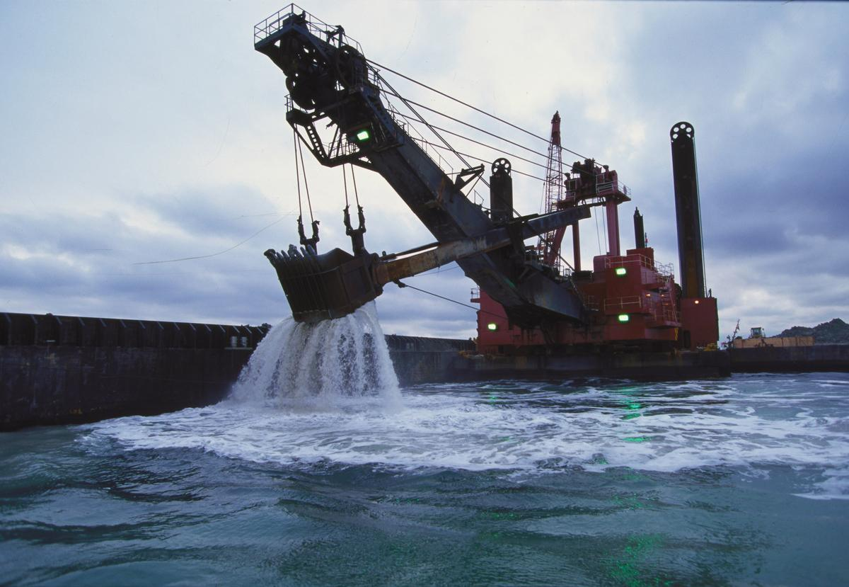

* Bow
* Frame
* Guy wires
* Boom, boom stick
* Dipper bucket
* Hoist cable

**Procedure:**

Grapple

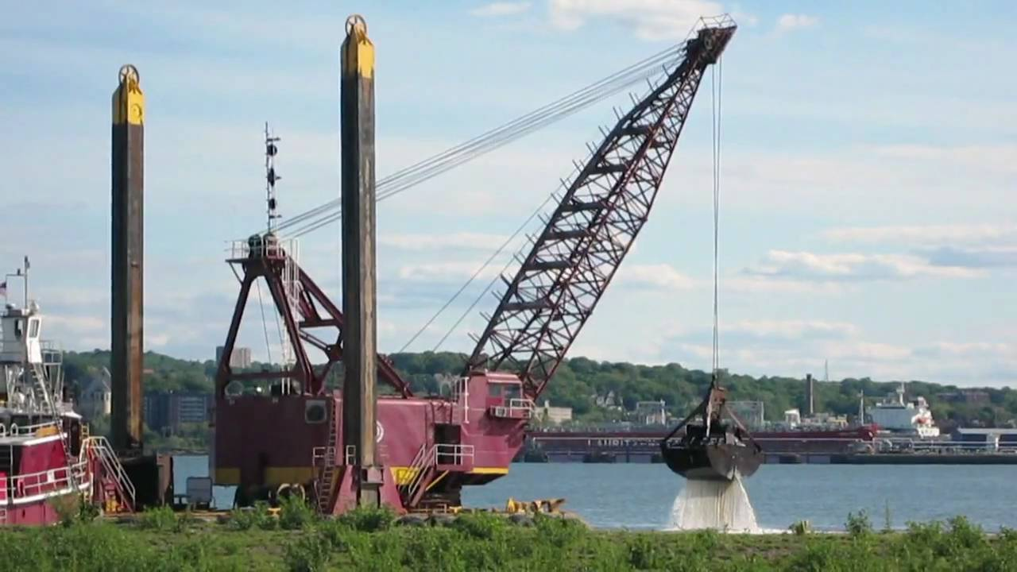

* Hull along with scow
* Frame
* Guy wires
* Boom
* grab bucket
* Operating and closing cable

**Procedure:**

Continuous or Ladder dredging

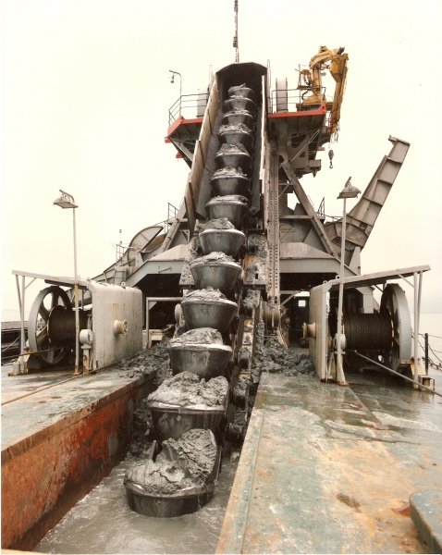

* Endless chains of buckets
* bow
* String or line N
* holds

suction or hydraulic dredging

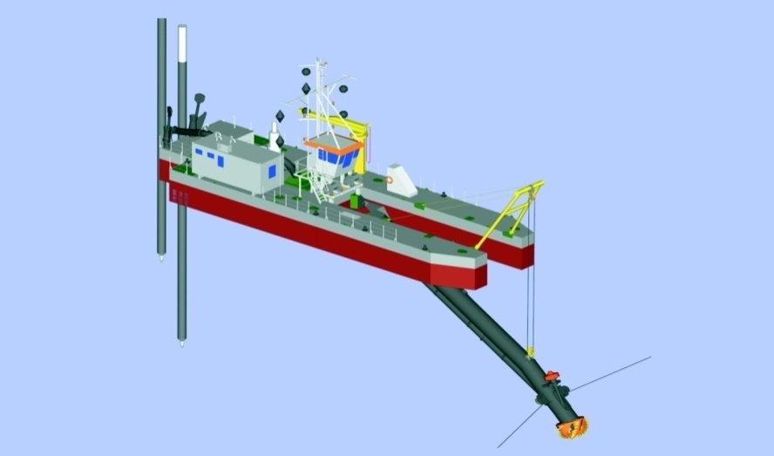

* Suction pipe
* Ladder
* cutter
* Centrifugal pump
* Hopper barges

Loading and Unloading Facilities

* Quays
* Wharves
* Piers
* Jetties
* Dolphins
* Fenders

Storage facilities

1. Apron
2. Transit sheds
3. Wearhouses

**Dock**

**Dock:** It is enclosed area for berthing of vessels to facilitate lording and unloading of cargos and embarking and disembarking of passengers or for repairs, fuelling, oiling, painting and watering of vessels. It may be wet or dry.

* **Arrangement of basin and docks**

*Shape:* it should suitable for shape of vessel.

*Rectangular:* length and breadth could adjustable give the maximum quayage

*Inclined pier:* consist of no of projecting piers into the basin

*Diamond:*same perpendicular distance b/w long sides, the long sides could be conveniently extended.

**Facilities provided**

* Lifting
* Compressed air
* Supply of fresh water
* Pulling equipment
* Anchorage facilities
* Supporting facilities

**Classification of Dock**

1. To facilitate loading And unloading
2. For repair

**To facilitate loading and unloading**

* To facilitate loading And unloading
* Wet docks In tidal basin
* In enclosed/Impounded basin

**Wet docks In tidal basin**

* Harbours are adversely effected by tides, which causes changes in water level.
* Port is protected by open sea coast outlying by breakwaters.
* In this pier walls are constructed at right angles to the shore alongside

**Advantages**

* speedy and unrestricted arrival and departure
* Lock gates for closing of entrance not required

**Disadvantages**

* If range of tide is more operations become
* Fluctuations of water level cause rubbing of sides of ships against berth

**In enclosed/Impounded basin**

* These enclosed or shut off by entrance by locks to maintain a fairly uniform level of water**.**

**Advantages**

* Uniform level water
* Prevent rubbing of sides of vessel
* Effect of storms doesn’t effect

**Disadvantages**

* Costly arrangement
* More time for entry and exit

**For repair**

* Fixed form
* Graving dry dock
* slipway
* Lift
* Movable form
* Floating

**Fixed form**

**Graving dry dock:**

* these are excavated chamber having side walls, end wall, front opening with gate and solid flooring. outer side is provided batter or stepped to increase width at base to make wall stable, against worst combination of loads.
* Principle of dry docking _____
* Size of dock depends on largest ship it has to dry dock. Generally a long dry dock is built in such a way that by introducing intermediate dock. Such arrangement allocate smaller vessels in place of big one.

**Dock empty**

* Floor will subjected to heavy uplift, which is more than the self weight of dock
* Weight of empty ship resting on the empty floor, add concentrated loads along the central lone of floor

**Dock filled with water**

* Horizontal pressure behind the side walls more or less resisted by inside water
* Inverted arch action will be absent under this condition of loading
* Surcharge loads

**Marine railway dry dock or slipway**: it is inclined railway extending from shore well into the water to enable a ship to be drawn up clear out of water.

* Essential parts are cradle, track which is supported on pile foundation
* This cradle constructed of steel, provided with keel and bilge blocks to receive. Cradle mounted on system of rollers which moves on iron tracks carried by longitudinal timbers supported on beams bearing on piles or other foundation.
* Strong cable attached to cradle
* Hauling is operated by mechanical winches
* Economical. But 50,000KN

**Lift dock:** it is capable of being lowered into and raised from water.

This process done by means of hydraulic power.Modern ships have considerably grown in tonnage and size so this ancient method is discontinued.

**Movable form**

**Floating docks:** these are floating vessels which lifts vessels from out of water and retain it above water by means of its own buoyancy.

* **Rigid type:**
* **Self docking :**
* **Self docking offshore type:**